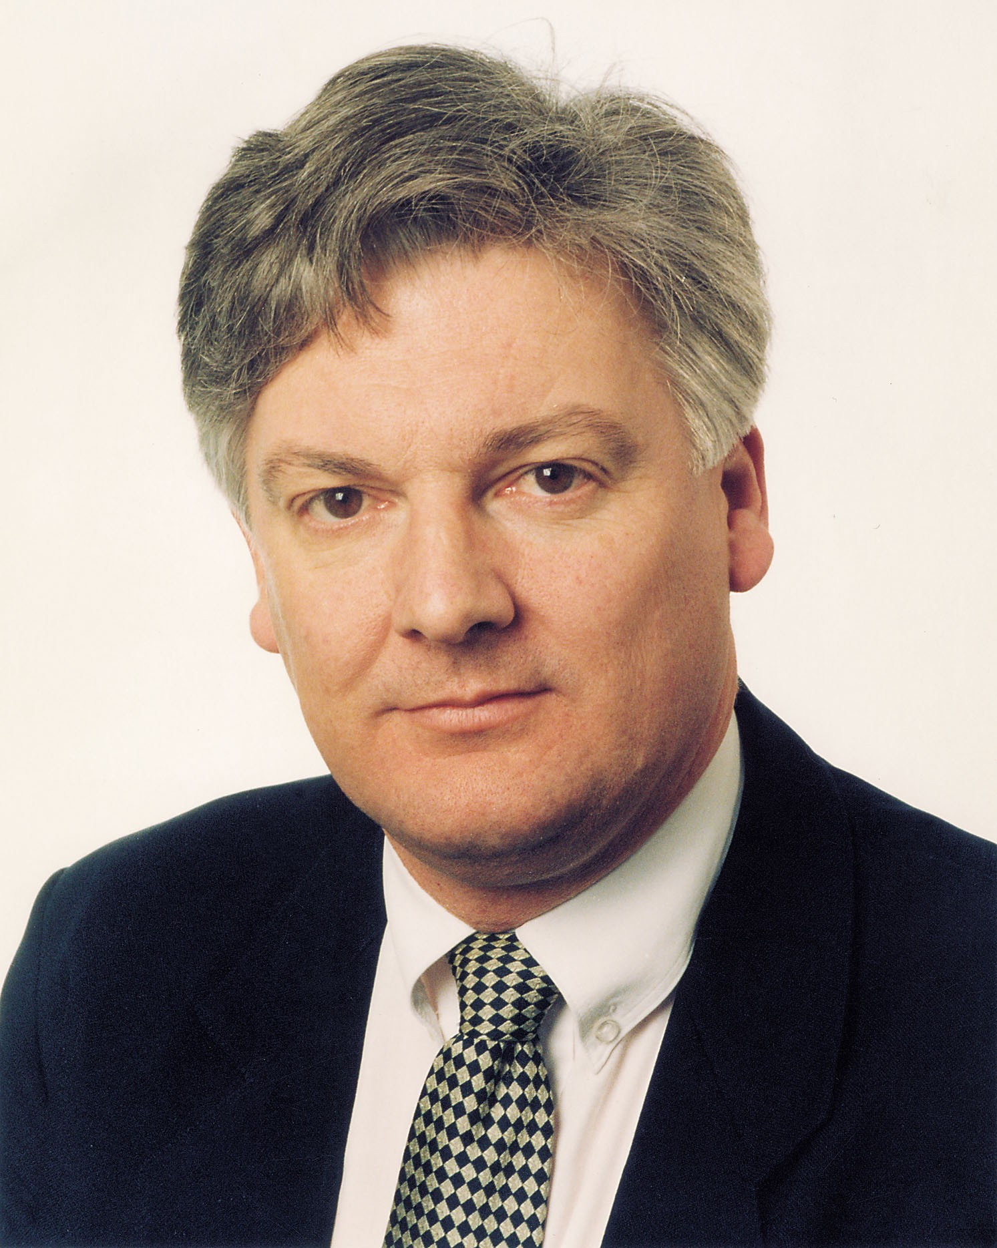

Events for your diary

Saturday 8 March, 8pm - United Future (Ohariu Belmont) coffee & pot luck dessert evening - at 24 Silverbirch Grove, Churton Park, Wellington. A wonderful opportunity to catch up with the United Future team and to meet party Leader, Hon Peter Dunne MP.
RSVP: by Saturday 1 March , to Roger or Marie Ellis, ph: 973 3913.

Monday 14 April, 8pm - United Future Ohariu Belmont Electorate Committee meeting - at 24 Silverbirch Grove, Churton Park. A planning session to ensure that 2003 is another great year for United Future and the families and communities we work for.

Electorate offices:

Johnsonville | Shirley Simcock | 3 Frank Moore Ave
Tel: 478 0076 | Fax: 478 7029 | P O Box 13 236  Johnsonville
Lower Hutt | Sue Locke | 66-80 Bloomfield Tce
Tel: 560 4775 | Fax: 569 2232 | P O Box 31 628  Lower Hutt

Congratulations to the voters of Ohariu-Belmont! You, and thousands of other New Zealanders like you throughout the nation, made it possible for United Future to show that we can make MMP work; that we can work with other parties to ensure that commonsense policies are developed so that our country can make true progress.

After just six months of the new Parliament, I can report to you it is working well and GOOD ON YOU for making it possible. You’re a star!
Regards,
Peter Dunne, MP

